High Med Consortium: Prevention and Chronic Disease Management Proposal
High Med Consortium will aim to maximize impact on patient health in the short to medium term on population health and long-term conditions. Regular reviews of patients and their treatment is a key element used to manage chronic disease and to prevention of further issues. For instance, ensuring that the right patients are prescribed statins (or alternatives including social prescribing of healthy interventions) to prevent and delay cardiovascular diseases. Therefore, we have chosen to focus this proposal on underperformance of Isleworth Practice in the Quality Outcomes Framework. This will have a material effect on patient health and provide good practice and learning that can feed into Brentworth and wider Hounslow PCNs.
Although we have made this proposal, this will not be isolation to carrying out and supporting Public Health Management activity and initiatives locally. For instance, the multi-faceted, multi-disciplinary approach of Integrated Neighbourhood Teams. Hounslow Care Together has launched in September 2025 to support residents with frailty and unmet health needs.
Background and Rationale
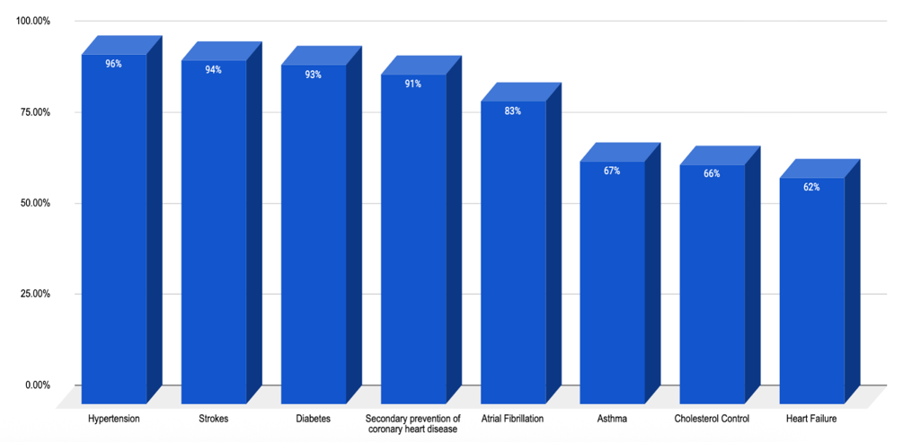
Following our review of the QOF 2024-2025 data for Isleworth Practice we have identified underperformance in the 8 (out of 21) clinical domain indicator.
The headline indicators reveals significant issues in several areas. For instance, 12-month reviews for asthma patients have an underlying achievement rate of 83% with a Personalised Care Adjustment (PCA) from the actual number seen of 35%. Therefore, only 54% of patients have had a review.
This underperformance creates high-risk levels to patient health due lack of essential reviews, medications not being given or adjusted, and incomplete records. For instance, only 9.7% of Heart Failure (net of PCA) have had an annual review including for their medication. Only 41% (64% net of PCA) of patients in this cohort have confirming echocardiograms or specialist assessment in their records.
Programme Design and Methodology
During mobilisation of the contract, PHM head, Dr Usama Safeer, will lead a review programme that uses the QOF data being produced by the practice alongside the 2024-2025 data for baseline purposes. He will identify areas that are underperforming and investigate the reasons why.
There are effectively two main areas of concern both of which can contribute or cause underperformance.
- What is the practice doing i.e., are there internal issues ranging from staff needing support to understand systems, poor day to day management, and lack of oversight in clinical governance
- What is causing the high PCA rates? Ranging from internal manipulation to high numbers of patients not attending.
In conjunction with the clinical leads for each Clinical Domain Indicator Groups, Dr Usama Safeer, will develop a programme of work (segmented by Clinical Domain) to resolve issues and bring the performance to expected levels; 100% for overall Group performance with Personalised Care Adjustment rates returned to London averages or better. Further, we will need to ensure that the programme brings an existing team with us on the journey to improvement.
The programme will not just focus on technical changes within the practice. It is likely that there will be issues within the patient population that are contributing to high PCA rates. Overcoming this will need focused outreach work and working with local partners and organisations; Brentworth PCN, Hounslow Care Together and Healthy Hounslow for instance. Further, we will need to overcome cultural issues locally. This will require a sensitive approach with community and religious organisations. We will appoint a member of staff as a Cultural Champion tasked with building relationships with local organisations and convincing them to support our programme to improve their community’s health.
Implementation (commencing 01 July 2026)
Implementation of the programme will require a practice wide, collaborative approach. Dr Usama Safeer will lead this and create a timed implementation plan with key milestones and responsibilities. Clinical Domain leads will head up each of their areas and be accountable for delivery of milestones supported by their clinical teams.
Dr Usama Safeer will maintain a complete project management approach to include, weekly team meetings attended by all Clinical Domain Leads and a monthly project meeting that feeds into our overall Governance Structure attended by our Clinical Director, Dr Shumaila Mahmood will also maintain a dynamic Risk Register that will feed into project management.
Impact and Evaluation Framework
Dr Usama Safeer will monitor the progress of each Clinical Indicator Group through use of clinical data available on SystmOne and through reporting completed by Clinical Leads focused on programme delivery. Our outreach work to improve patient engagement will be monitored through matching attendance rates against the patient list broken down into Clinical Indicator Group and through reporting from our Cultural Champion.
All reporting will be reviewed against the overall Programme Plan timeline and milestones. Underperformance will be addressed through immediate action plans. As part of our continuous improvement process, Dr Fareed Nasir will use the review process to identify improvements to our delivery plans and implement through our Project Management approach.
Overall progress and performance of the project will feed into our Clinical Governance Cycle as a standing agenda item at monthly meetings. We will also report into Brentworth PCN, wider Hounslow PCNs, and the ICB to ensure rigorous oversight and that learning is disseminated appropriately.
Conclusion
Our chosen approach to preventative or chronic disease management will have tangible results within our first year of operation and improve the health of patients registered at Isleworth Practice. Further, results will have an impact and be nationally visible in the QOF for the August 2027 release.
regular reviews of patients at Lanark Practice to see age disparities noted for cervical smear clinic attendance. ( 65% uptake in Asian woman of age 25-40- we concluded this was due to working hours and we provided out of hour late/ weekend clinics

Name | Focus area | Previous experience
Dr Shumaila Mahmood | Smoking cessation; substance misuse support; obesity risk coding | - Launched a smoking-cessation campaign within routine practice, tracking adherence for >120 patients in 2024  - Established monthly drug & alcohol support services with the ARCH Clinical Nurse Lead at HESA Medical Centre since 2021, with integrated monitoring for patients on prescriptions from drug & alcohol services  - At Lanark Medical Practice, oversaw accurate coding of patients with BMI >30 to ensure correct care pathways and referrals and audit of cervical smear clinic and improvement (i.e., 65% uptake for Asian 25-40 yr improved via extended opening hours)
Dr Saira Safeer | Smoking awareness & prevention | - Organised and led a Smoking Awareness Programme at St Mary’s Hospital (Aug 2022–Aug 2023) in collaboration with Dr. Kon (respiratory consultant) initiative based on Cerner audit data (2000–2023) showing rising smoker identification; provided cessation help and awareness; >40% of patients reported feeling more informed after initial consultations; outcomes presented at the Respiratory Trust-wide MDT.
Eda Erturk | Dietetics; lifestyle & behaviour change; mental health–informed chronic care | - Specialist Dietitian with leadership training and extensive experience running specialist clinics; worked in Tier 4 Mental Health Services at the Collingham Child and Family Centre, supporting patients holistically (exercise, diet, psychological wellbeing) to promote long-term, sustainable health improvements and behavioural change
Dr Usama Safeer | Population health; therapeutics for chronic disease | - Worked with NHS England assessing population-wide needs; conducted multiple global and nationwide assessments of population health measures (e.g., related to GLP-1 agonists).
Dr Fareed Nasir | Isleworth population expertise | - Population health management initiatives at Sunrise Medical Centre and HESA medical centre; bringing a wealth of local population knowledge

